Spectra Nova Copy and Designs
2009
Cooking stoves and organic fuels technology development projects

Ecological responsible projects run by VOICES FROM THE FOREST, a sustainable resources business consortium in Nigeria. The projects; which are open to collaboration include developing interactivity and organic fuels for cooking stoves and bush regeneration.
Backgrounds to the projects as well as results from experiments carried out by the consortium are also included in the project

VOICES FROM THE FOREST SUSTAINABLE RESOURCES BUSINESS CONSORTIUM
7, JIDA ROAD, AGBARA INDUSTRIAL ESTATE, OGUN STATE, NIGERIA

Tel:

+234-(080)23019541
+234(070)81197886

E-mail:

Tolu Ojo
toluwalaseojo@yahoo.co.uk
Project Co-coordinator
Petfarm, Nigeria,

Akin Olatidoye
poetikcaves@yahoo.co.uk
Media and Market Research
Spectra Nova Copy and Designs

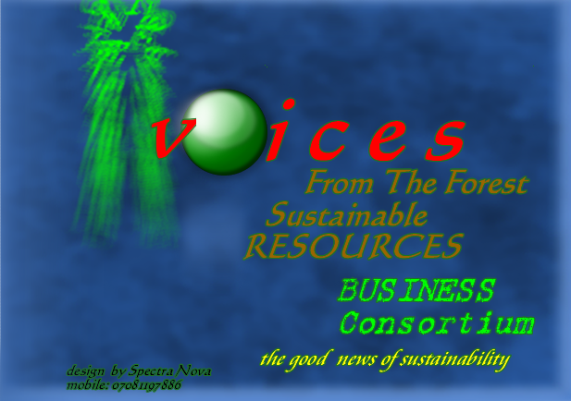

CONTENTS

GENERAL INTRODUCTION
page 3
INTRODUCTION TO COOKING STOVES AND ORGANIC FUELS DEVELOPMENT PROJECTS
Page 4
PROJECT 1: MAXIMIZING interactivity in user focused DESIGNS COOKING TECHNOLOGIES FOR SUSTAINABLE fuel use
page 5
PROJECT 2: development of compact and efficient organic-based fuel capsules for cooking STOVES AND BUSH REGENERATION PAGE 9
CHEMICAL PROPERTIES RESULT FROM DOMESTIC COMPOSTING BIN EXPERIMENt page 10
APPENDIX OF TABLES AND PICTURES PAGE 13

general introduction
THE VOICES FROM THE FOREST Sustainable Resources Business Consortium, Nigeria (founded September 2007); Is an enterprise network incorporating interests as diverse as from the media, performing arts and music, business development and environmental conservation.

PROJECTS
Since its formation in September 2007 the consortium has engaged in the research and developments of following projects:
ADVOCACY AND AWARENESS CAMPAIGNS
Studio Recording of Album on thematic songs and commentaries:
Bata’De, The Voices From The Forest. April 2008
Public advocacy and campaign presentation at major stakeholder’s forum:
Nigeria Conservation Foundation Annual Dinner And Award Night, Friday 28
November, 2008

Organic waste recycling and development
Bush regeneration
Bioremediation
Landfill gas production
Effluent /Waste water to gas recycling
Underutilized plants species identification and marketing
Underutilized plants species identification and marketing

COOKING STOVES AND ORGANIC FUELS TECHNOLOGY DEVELOPMENT PROJECTS

INTRODUCTION
Cooking stoves are tied to many issues with a global reach. These include sourcing for healthy, less ecological disruptive fuels and maximizing responsible user focused designs as true symbols of domestic usefulness and efficiency.
This for instance has led to appreciable developments such as Bio energy Lists, a web archive of information to help develop better stoves with biomass fuels in developing regions. One can also mention The Partnership for Clean Indoor Air (PCIA) and its Partners around the world whose aims are to increase awareness and action on indoor air pollution, household energy and health.
Engineers In Technical and Humanitarian Opportunities Of Service ( ETHOS) CONFERENCES which feature presentations, workshops, and discussion of technology in the developing world also includes thematic focuses on heating and cooking stoves, design for developing communities, incineration of medical waste, and lighting is equally another note worthy development.
Research efforts at THE VOICES FROM THE FOREST SUSTAINABLE RESOURCES CONSORTIUM, NIGERIA are also streamlined with the flow of these laudable insights and action on cooking stoves which fall within the scope of its larger vision of guarantying the fulfilment of ensuring environmental sustainability, the important Millennium Development Goal 7 of the United Nations set in 2000.
In this regard, THE VOICES FROM THE FOREST SUSTAINABLE RESOURCES CONSORTIUM NIGERIA maintains a double project portfolio on cooking stoves namely:
- MAXIMIZING interactivity in user focused DESIGNS COOKING TECHNOLOGIES for sustainable fuel use.
- development of compact and efficient organic-based fuel capsules for cooking stoves

The former project is a charge of the Information technology unit of the consortium, whilst the latter is handled by the Recycling and Organic technology unit.

PROJECT A: MAXIMIZING interactivity in user focused DESIGNS COOKING TECHNOLOGIES FOR sustainable fuel use.
Introduction
Background work on this project includes an abstract which the consortium was privileged to send to ETHOS 2009 in Seattle. It focused on developing interactive elements for cooking technologies, using the case of THE WHEEL, developed in India
MAXIMIZING interactivity in user focused DESIGNS COOKING TECHNOLOGIES for sustainable fuel use: the CASE of the indian stove
You’ll run out of posts before you run out of Texas is a dictum equal to Interactivity(calibrations and measurements), which is a key issue in Lateral thought patterns for user focused designs and a firm approach to sustainable fuel use. It underscores the following key values: Responsibility; conservation; inventiveness; prosperity.
Hands on experience with an Indian Cooking stove invention highlight these prime values. The kerosene stove called the Wheel is a double burner kerosene stove; with a fuel tank and a hydraulic pump that allows a gradual regulation of kerosene into the burners and also of the flame produced!
At its current visible best, the wheel is a baseline technology with the right values but with some great potential for development in the areas of interactivity.
The fuel tank is a blind spot needing options in interactivity. The Hydraulic pump is some gym equipment that can take its stride into two great ways. First, the pump can be more automated for time-saving efficiency and second, when fitness and responsible technology, the manual pumping can be synchronized with the parallel brilliant idea of generating electricity from gym thread mills!
Recommended Collaborative Project work: Workshop project exploring elements of object programming for analogue data sensors compatible with cooking stoves.

Working statement.
- If light= 0 mass + Infinite energy for {values} then Heat of {values in order.....} is produced by combustion of kerosene of quantity {values in order....} applied through pressure of {values in order......}

Table 1

PHOTO CLIPS OF THE WHEEL DOUBLE KEROSENE STOVE
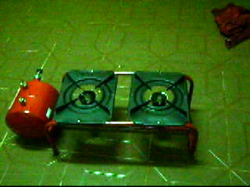
(fig 1) Full picture of the wheel double kerosene stove.

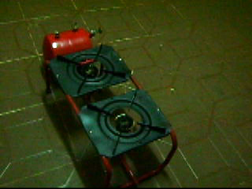
BURNER
FLAME
CUP
PUMP
PISTON
FUEL
TANK
( Fig 2 ) Labelled picture of the Wheel.

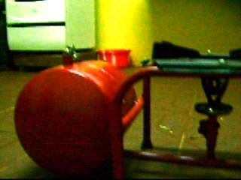
(Fig 3) Work target for interactive user friendly design: The Tank and burner!

PROJECT TARGETS

THE PROJECT targets benefits in
- Information technology development for cooking stoves technology
- Sustainable Fuel Use

PROJECT NEEDS
- Educational workshop for development of working statement
- Patenting of results of workshop project
- Technical incorporation of patented results into exsisting user focused designs

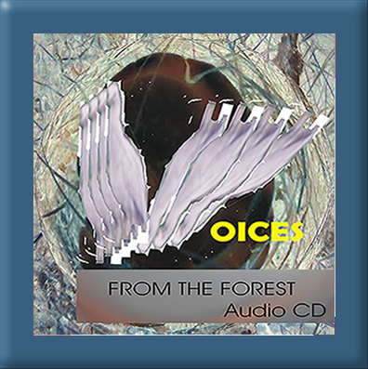
Some Useful facts:
Over a third of the global
- Economy is based on biological products and processes
- Landfill gas engines also generate electricity
- One ton of biomass will produce the energy equivalent of 60 gallons of crude oil
- Methane is produced when biomass like your kitchen waste is exposed to certain bacteria.
- UNDP(United Nations Development Programme has one of the largest energy and environment portfolios building capacity at the country level
- A huge information gap exists on climate change and sustainable resources use issues in Africa.

Premium Quality entertainment on resource sustainability and climate change awareness. Features songs, poetry and commentary in Nigerian Languages.
Produced by THE VOICES FROM THE FOREST SUSTAINABLE RESOURCES CONSORTIUM international.
Mixed And Recorded at O.T.M studios, Badagry, Lagos State.

WATCH ‘AFTER THE SILENT SPRING: REAWAKENING
THE VOICES OF THE FOREST’; a silent movie produced by The consortium on www.quantumshift.tv/v/1214575982

PROJECT B: development of compact and efficient organic-based fuel capsules for cooking stoves

INTRODUCTION
Background work on the project started with A casual learning visit made to a pastoral Fulani-Nigeria community by Akin Olatidoye (Media and Market research officer of the Consortium); then a team member of an international youth exchange program* between the United Kingdom and Nigeria in December 2001. After the discovery of the need of participating in a concerted global drive towards taking proactive steps to reducing ecological footprint impact due to the sourcing of fossil fuels, The Voices from the Forest Sustainable Resources business consortium, Nigeria ran a domestic Organic composting bin experiment project. Encouraging results from the experiment project snowballed into the vision of developing compact and efficient based fuel capsules for cooking stoves.

STRATEGIC RESULTS FROM DOMESTIC ORGANIC COMPOSTING BIN EXPERIMENT PROJECT RUN BY THE VOICES FROM THE FOREST, ECO-SUSTAINABILITY BUSINESS CONSORTIUM, NIGERIA.

A composting bin system comprising of two plastic containers (Control and Experimental) with covering lids and a base outlets plugged with wire gauze and absorptive material (cotton balls) which ran to a retainer.
Organic materials ranging from cooked food waste, fresh tuber peelings, vegetables stalks, semi-dry leaf wraps, dry twigs (pawpaw), decaying fruit material, dry grass, fine brown sawdust and ash were stalked into layers into the control and experimental bins in a ratio 1:2 . The feedstock was wetted for an average of 21days.
On the 9th day of wetting: sharp pungent gaseous emissions and smell observed from (untraped and untested by a gas analyzer)
At the end of the wetting period
2kg of decomposed (semi-solid) substrate material from the composting bin (control A and control B) was analyzed for physico-chemical properties and indicated:

Moisture: 77.97percent
Nitrogen 0.59 percent
Phosphorus: 8.96 percent
Potassium: 28.90 ppm
Zinc: 6.46 ppm
Copper: 4.62 ppm
Cadmium: 0.71ppm Table 2

Compost tea obtained from retainer, with dark brown appearance was analyzed for physico-chemical properties and indicated the following results:

P.H.: 6.96

Ammonical nitrogen: 16.8 ppm
Nitrate: 0.35 percent
Potassium: 8.63 ppm
Table 3

LEVEL 1 SCHEMATIC: development of compact and efficient organic-based fuel capsules for cooking stoves
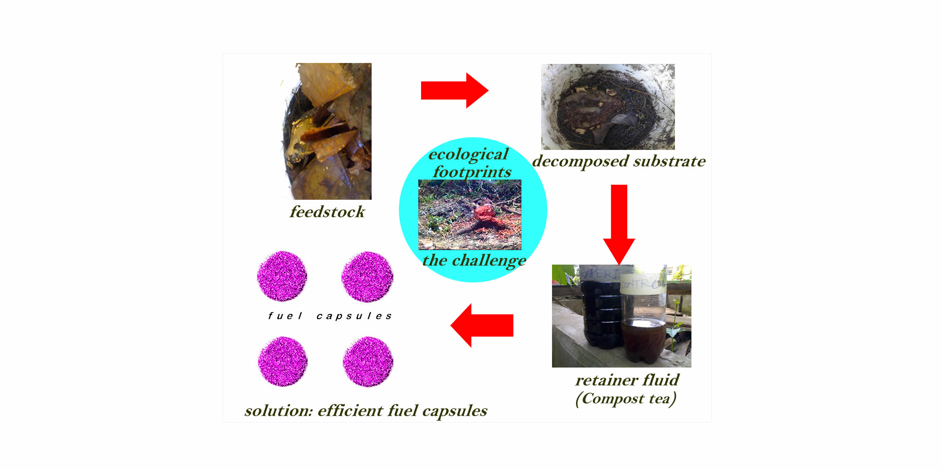
Fig 4: Level 1 Schematic: Development Of Compact And Efficient Organic-based fuel capsules for cooking stoves.
The broad aim of the project is to combine the end offerings of the Kitchen waste bio-fermenter (started by cattle dung) and Organic composting bins. Differing only in the combination and variety of the feedstock used; both processes can be synergized into a final product which is compact and efficient; eliminating for the domestic end user, time and energy spent in the monitoring of chemical processes and as well as adding great value in being clean, portable and odour free. The project also has high-ended potential for stimulating service-oriented industry in cooking technology sector.

PROJECT NEEDS

- Development and Experimental testing of level 1 schematic
- The domestic composting bin project was carried out in an open air system, without some vital gadgets and access to some vital equipment including the following:
- Gas analyzer
- Bubble Chamber
- Internet facility for remote PC networking for instant reporting
- Surveillance cameras

- PATENTS
- Proprietary information and results from project need patents. Certified copies of chemical properties from the experiment available on demand.

APPENDIX
Pictures
Fig 1: Full picture of the wheel double kerosene stove.
Fig 2: Labelled picture of the Wheel.
Fig 3: Work target for interactive user friendly design: The Tank and burner!
Fig 4: Level 1 Schematic: Development Of Compact And Efficient Organic-based fuel capsules for cooking stoves

Tables
Table 1: Abstract: MAXIMIZING interactivity in user focused DESIGNS COOKING TECHNOLOGIES for sustainable fuel use: the CASE of the indian stove

Table 2: physico-chemical properties 2kg of decomposed (semi-solid) substrate material from composting bin experiment.
Table 3: physico-chemical properties for Compost tea obtained from retainer.

Highlight: * International youth exchange program: Millennium Awards, International Voluntary Exchange Programme, joint initiation of The Prince’s Trust, Voluntary Services Organisation (VSO), Life Vanguards, and Nigerian Youth Based NGO. Learning visit made by Ms Demelza Spruce and Akin Olatidoye to Pastoral Fulani Community on the outskirts of Ede, town in bio-borderline between Rain Forest and Sahel Savannah regions, South-West Nigeria; December 2001

Ref:Voluntary Services Organisation
317 Putney Bridge Road
London,
SW15 2PN
United Kingdom.

